|  |
| --- |
| *mm/dd/yyyy* Name |

Project Design Document

# Project Concept

|  |
| --- |
| **1**  **Player**  **Control** |

|  |  |  |  |
| --- | --- | --- | --- |
| fighter jet |  | Top-down | game |

|  |  |  |
| --- | --- | --- |
| mouse clicks |  | shoot bullets towards clicked positions |

You control a in this

where makes the player

|  |
| --- |
| **2**  **Basic**  **Gameplay** |

|  |  |  |  |
| --- | --- | --- | --- |
| balloons | appear |  | the bottom of the screen |

|  |
| --- |
| pop as many balloons as possible before they reach the top |

During the game, from

|  |
| --- |
| *Any other notes about the project that you don’t feel were addressed in the above.* |

|  |
| --- |
| **6**  **Other**  **Features** |

|  |  |  |  |
| --- | --- | --- | --- |
| power-ups | will appear |  | faster shooting or explosive bullets |

and the goal of the game is to

|  |
| --- |
| **3**  **Sound**  **& Effects** |

|  |  |  |
| --- | --- | --- |
| popping sounds when balloons burst and popping sounds when balloons burst |  | small explosion particle effects when a balloon is hit |
| [*optional*] There will also be |  |
| screen shake when multiple balloons are hit in quick succession | | |

There will be sound effects and particle effects

|  |
| --- |
| **4**  **Gameplay**  **Mechanics** |

|  |  |  |
| --- | --- | --- |
| balloons will spawn faster |  | harder to hit them all |
| [*optional*] There will also be |  |
| different types of balloons (some need multiple hits or move in patterns) | | |

As the game progresses, making it

|  |
| --- |
| **5**  **User**  **Interface** |

|  |  |  |  |  |
| --- | --- | --- | --- | --- |
| The score |  | will increase |  | whenever a balloon is popped |

The will whenever

At the start of the game, the title and the game will end when

# Project Timeline

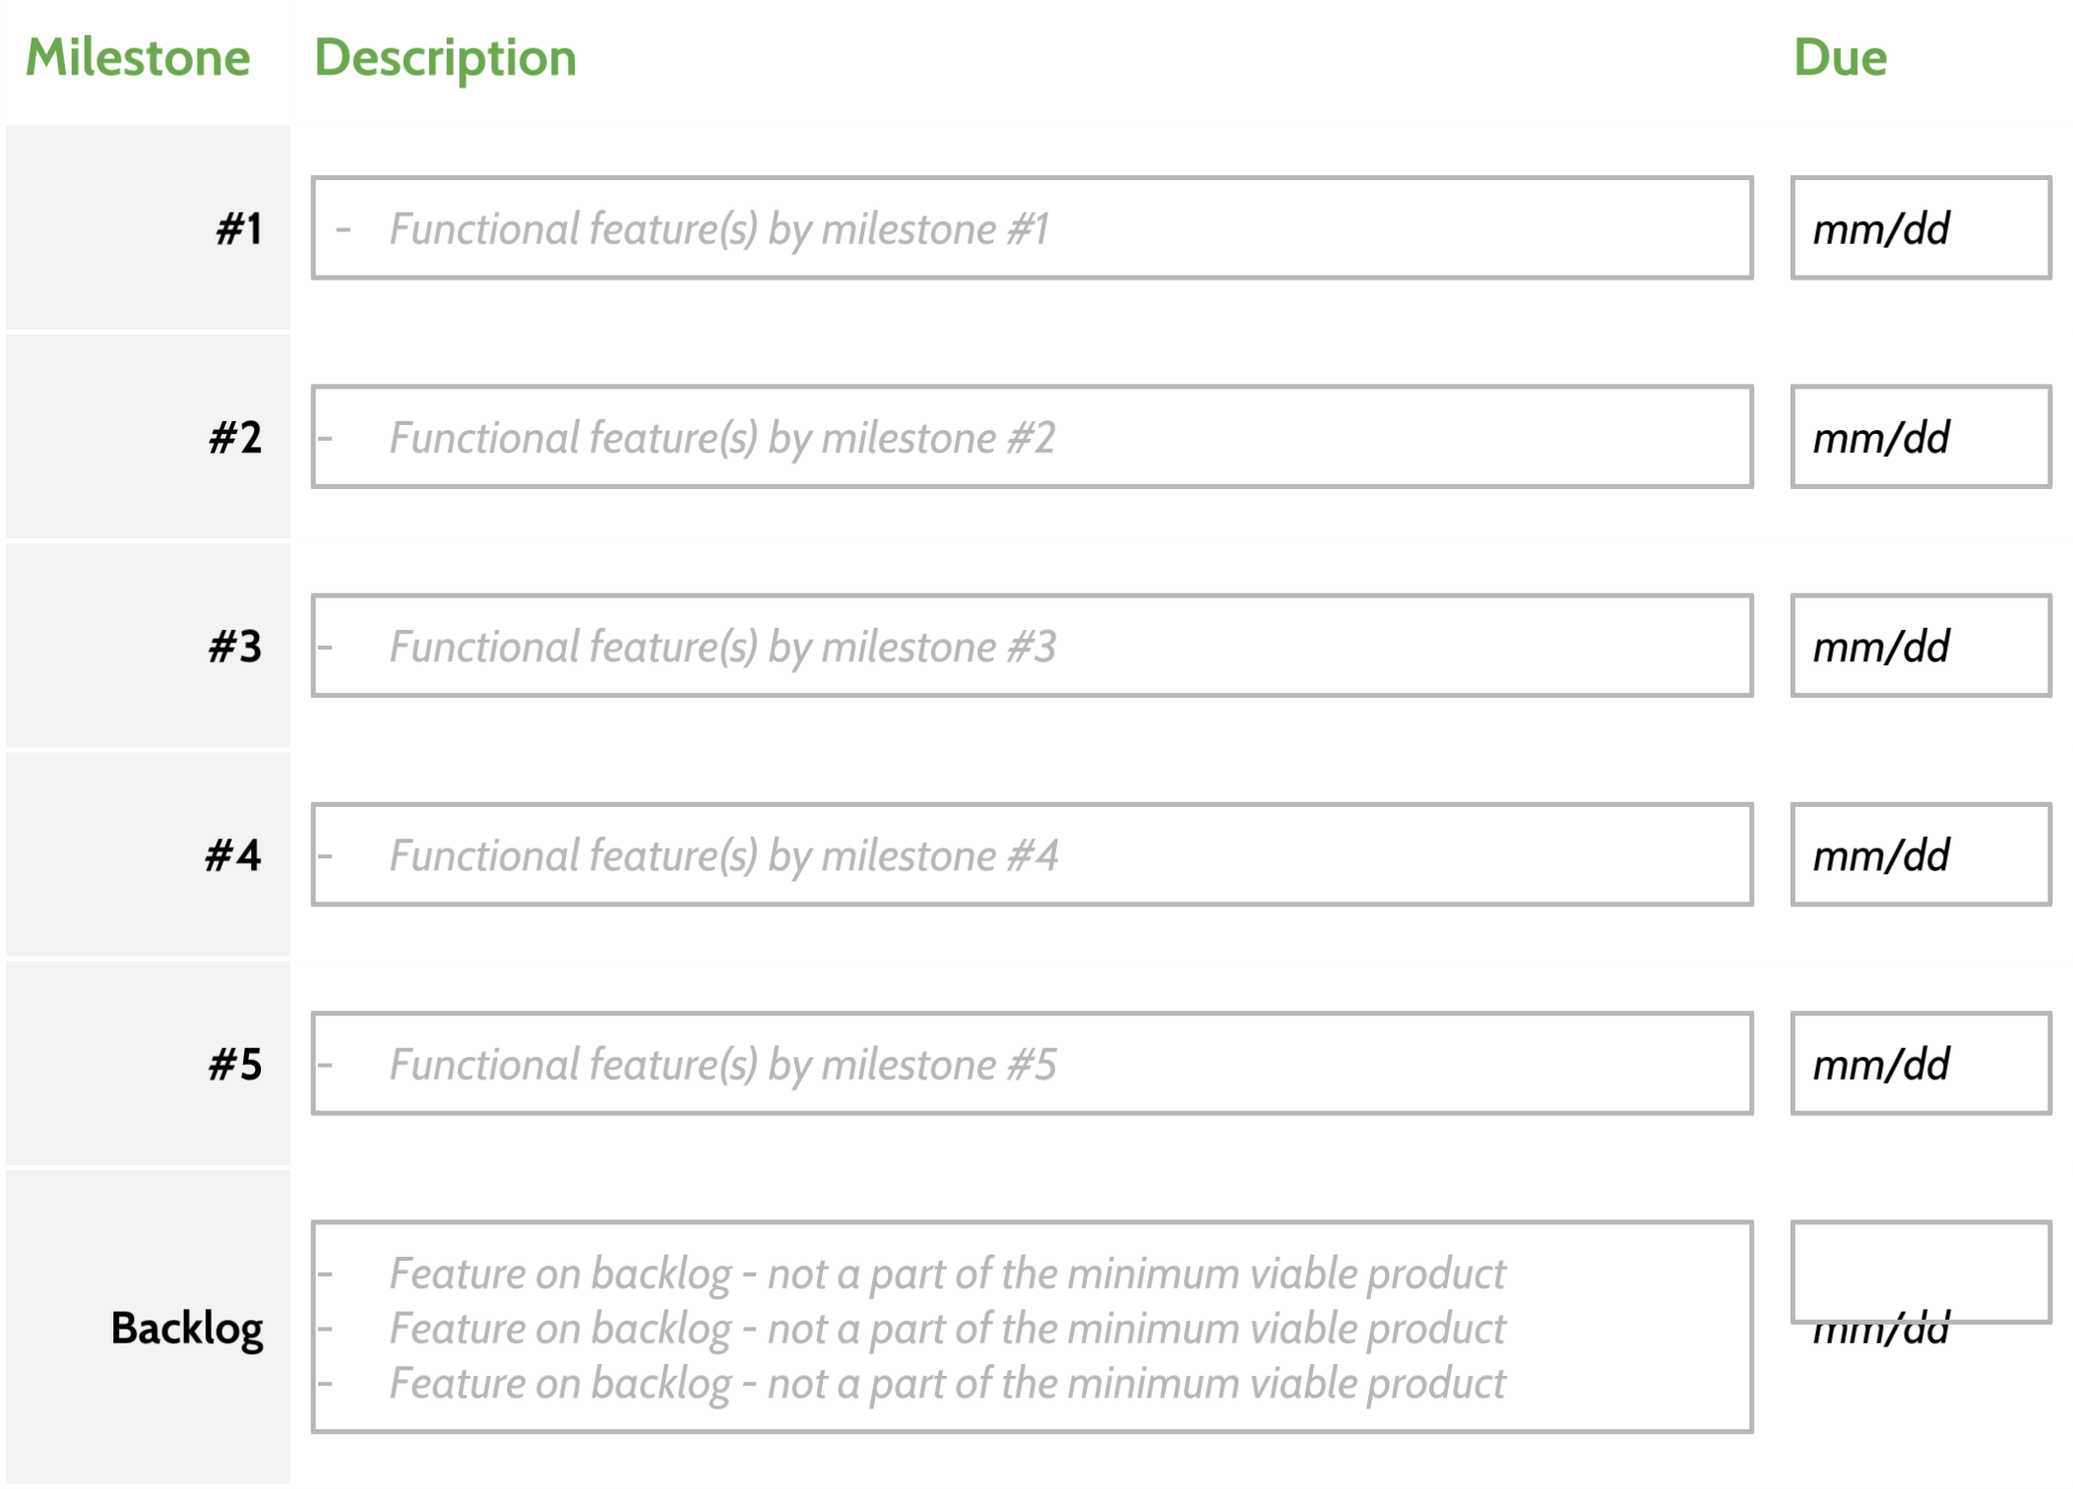

Milestone: Timeline: Due date:

#1: Basismechanica: vliegtuigbeweging en schieten implementeren 10-02  
#2: Ballonnen genereren en vernietiging bij schot toevoegen 11-02  
#3: Scoremechanisme en moeilijkheidsprogressie (snellere ballonnen) toevoegen 12-02  
#4: Geluidseffecten en explosiepartikels bij vernietiging van ballonnen implementeren 13-02  
#5: UI en game-over systeem toevoegen en testen 14-02

Project Sketch

